1. Go to http://connected.mcgraw-hill.com/ and click to “create a new account.”
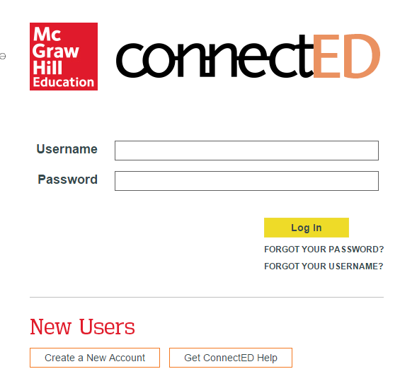
2. Enter the redemption code: L1VE-49PX-NGGO; Then click “Register.”
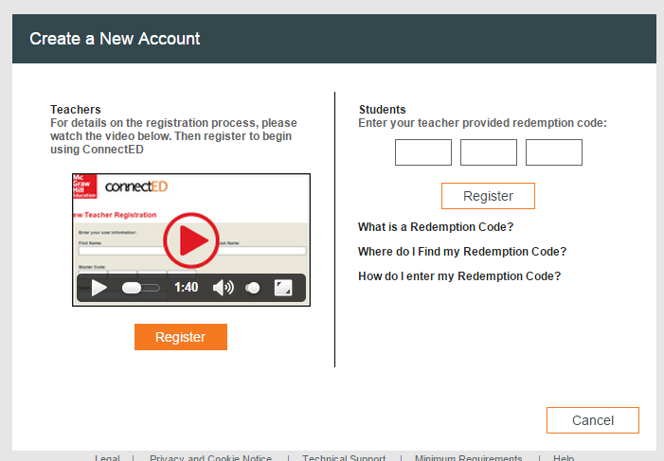
3. Enter your first name, last initial, and the 1st 6 digits of your student ID; then click “Finish.”
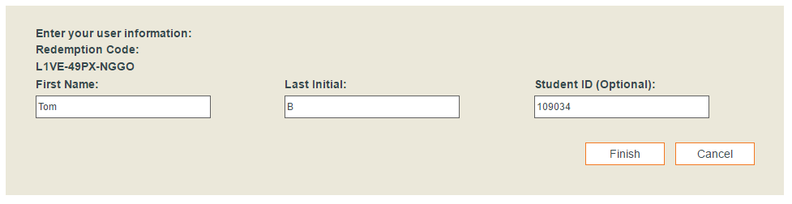

4. Print or write down your user name and password (they are case-sensitive), and keep them in a safe place; then click “Continue.”
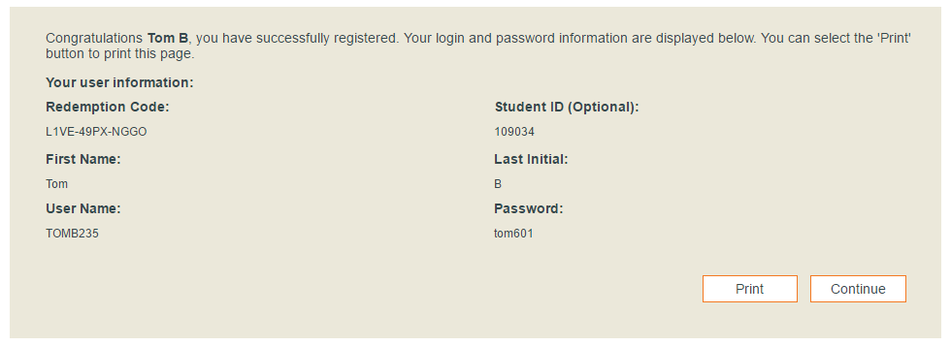

5. Click on the picture of the book.
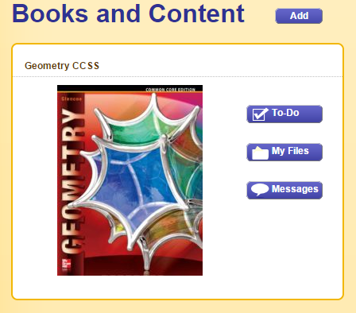
6. Click on eBook.
